1. **Home Screen :**

The interface is designed in the form of Tiles on the screen format thus giving the user a view of all possible things he can do with the application without looking around and pressing for too many buttons. Images are provided coupled with text that define the action that takes place on clicking that particular tile. The arrows on the tile show the direction in which the screen moves on clicking the tile.Also, there is a dropdown provided with an option to change the language of the app.

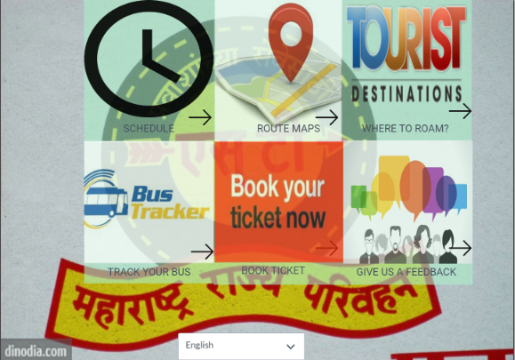

Screen 1 : English Home Screen

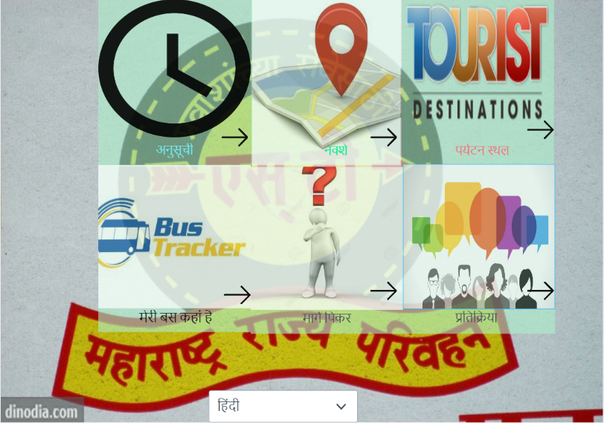Screen 2 : Hindi Home Screen

1. **Bus Schedule Screen** :

On clicking the schedule tile, there is a dropdown provided which contains the bus numbers and after the user selects the bus number, the schedule of the bus at every bus stop along the route is shown .

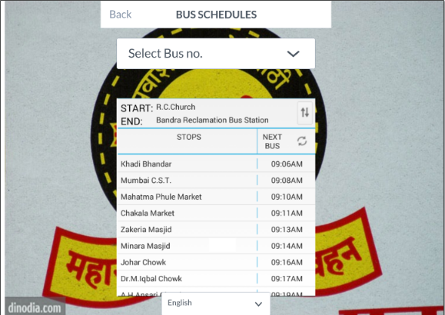

Screen 3 : Bus Schedule Screen

1. **Route Finder** :

The next tile is the “Route Finder” which helps to find the routes between a source and a destination which has to be selected after which it shows buses that the user can take and the amount of time approximately it will take to reach there. Besides, it shows the location of the bus stand with a blue dot on the map and the destination on the map with a location icon.

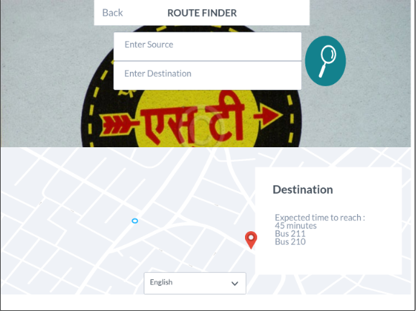

Screen 4 : Route Finder Screen

1. **Tourist Destinations** :

Clicking this tile results in showing the nearest tourist destinations and the bus numbers to take in order for the passengers to reach those places and current location as a blue circle.

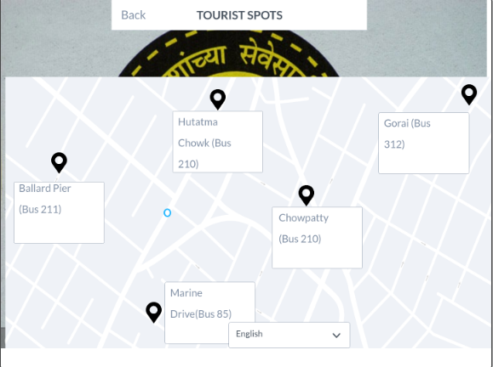

Screen 5 : Tourist Destinations

1. **Bus Tracker** :

This screen tracks the current location of the bus after the user selects the bus number from the dropdown that is provided.

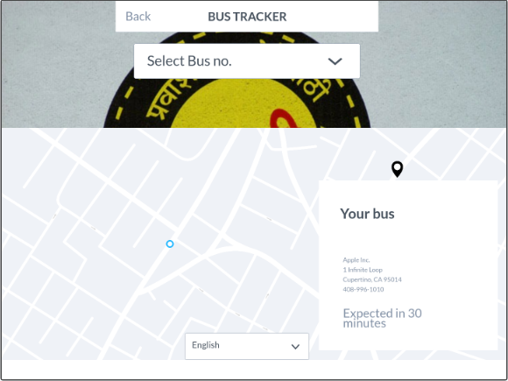

Screen 6 : Bus Tracker

1. **Book Tickets** :

This windows allows you to book tickets via the Kiosk machine by entering all details asked such as source, destination, no. of passengers and providing the smart card number.

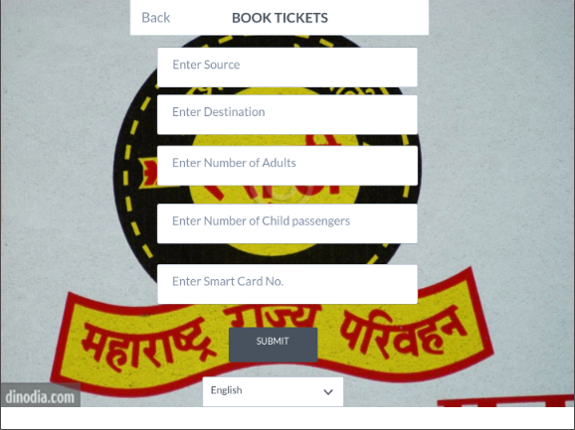

Screen 7 : Book Tickets Screen

1. **Give Feedback Screen** :

A screen has been provided in order to provide feedback regarding the service and the app in general.

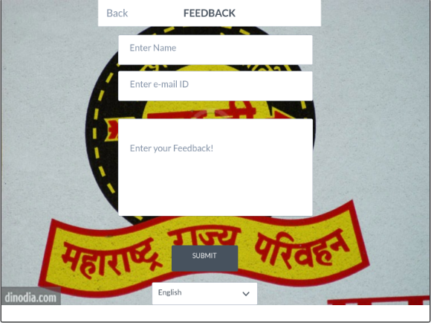

Screen 8 : Feedback Screen